PROJECT PLAN

members: Ishant upadhyay, Ji nan, Raditya surya pratama, hamid reza, hasan lapa,francky Ngabo

Group-B

Traffic-kings

2015

Contents

**INTRODUCTION** 2

**PROJECT STATEMENT** 3

1. Formal Client 3

2. Project Leader 3

3. Current Situation 3

4. Project justification 3

5. Project Product 3

6. Project deliverable and non-deliverable 3

Deliverables: 3

Non-Deliverable: 3

**Project Constraint** 3

Time 3

Programming techniques and tools for development 4

**Risks** 4

1. Problem to manage time 4

2. Beginners not a Professional 4

3. Requirement 4

**Project Phasing** 5

Phase 1: Requirement Gatherings 5

Phase 2: Initiations 5

Phase 3: Building 6

Phase 4: Finalization 6

**Project Management** 7

Skills 7

Quality 7

Time 8

Time schedule 8

Information 8

Abbreviations 9

Organization 9

# **INTRODUCTION**

In this Project, we will be working on software which will control the traffic light according to the Client’s need.

The traffic light will reduce the number of accidents, traffic jams and other undesirable situations on the road. There are six students working in this project and the purpose of this project is to learn how to use C# in bigger applications, learn to cooperate with other programmers and to know what documents are required in project work.

## **PROJECT STATEMENT**

## Formal Client

Mr. George, who is primarily responsible for the traffic situation.

## Project Leader

Ishant Upadhyay, student at Fontys Hogeschool.

## Current Situation

At the current moment there are many accidents and traffic jam. There is no software for simulating the traffic.

## Project justification

In order to reduce the number of traffic accidents, the software is required to simulate and discover the effect of traffic light on decreasing the number of accidents.

## Project Product

We will deliver a working traffic simulation program that will simulate the traffic situation according to client’s needs.

1. Project deliverable and non-deliverable

### Deliverables:

* Provide the actual application and the code.
* Provide a process report and a final presentation with a demo of the application.
* User Manual
* Technical Manual (description of methods, properties and classes).

### Non-Deliverable:

* Training of the users of the application
* Application running on an android device (Phone, tablet…).
* Support after the final acceptance of the software by client.

## **Project Constraint**

### Time

We have 1176 hours approximately to deliver the project. We have a lot of ideas but cannot implement them due to lack of time.

### Programming techniques and tools for development

C# Language is used to develop the software.

## **Risks**

### 1. Problem to manage time

We may face a time limit problem if a member of our group gets an unexpected situation.

***Effect on project*:**

It may create problem in completion of the project. We may run out of the time and not be able to finish the whole project in a professional way.

***Possible solution***

We will redistribute the remaining of his part equally among the rest of the members. Will give more hours for it individually.

### 2. Beginners not a Professional

Since, we all the students of ICT, we are still in the learning phase.

***Effect:*** It will have some effect on our work. We may deliver a low quality product at the end.

***Solution:***  We will take help from different learning sources as well as help of our teacher.

### 3. Requirement

Client may increase the requirement of function of the application.

***Effect:*** will affect our project as we have limited time.

***Chances:*** I see there is less chances that client will increase the requirement of project because we already discussed what we will deliver.

***Solution:*** will make a MOSCOW list and approve from client which are must requirement for this project

# **Project Phasing**

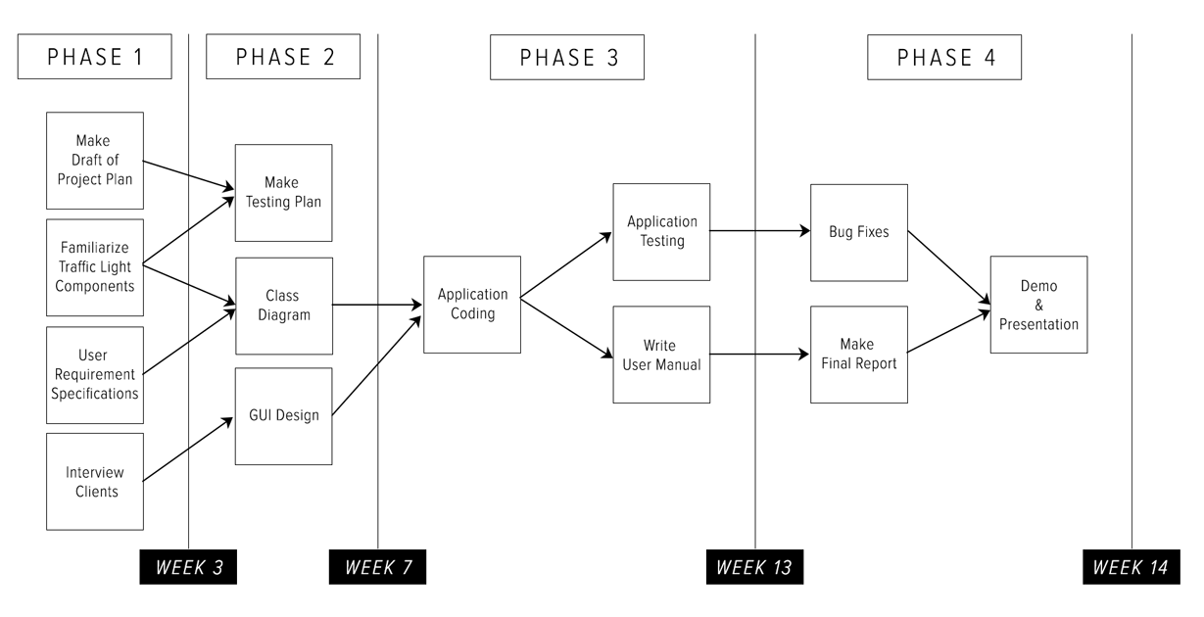

## Phase 1: Requirement Gatherings

Activities of this phase are:

1. Make a Draft of Project Plan
   1. Project Statement
   2. Project Phase
   3. Project Management(MOSQUITO)
2. Familiarize Traffic Light Components
3. User Requirement Specifications
   1. Uses Cases
   2. Function Requirements
   3. Non-Function Requirements
4. Interview Client
   1. Create Questions

Deliverables for milestone **P1** are:

1. First Draft Project Plan
2. URS

## Phase 2: Initiations

Activities of this phase are:

1. Make Testing Plan scenarios
2. Class Diagram
   1. Discuss Class Diagram
   2. List every class with description
3. GUI Design
   1. Create GUI Sketches of the application

Deliverables for milestone **P2** are:

1. Test Plan
2. GUI Sketches & Wireframe
3. Class Diagram

## Phase 3: Building

Activities of this phase are:

1. Coding the application
2. Test the application
3. Write the manual

Deliverables for milestone **P3** are:

1. C# Application
2. User Manual
3. Testing Report

## Phase 4: Finalization

Activities of this phase are:

1. Bug Fixing
2. Make Final Report
3. Demo & Presentation

Deliverables for milestone **P4** are:

1. Final Report
2. Final Version of C# Application

# **Project Management**

**Project Profit:**

At the end of project, we will be rewarded with 7 ECs.

The final grading will be given by our tutor.

### Skills

* **Project Management**: For all members, certain skills are required to make sure the project runs smoothly.
* **URS**: members must have good knowledge about designing user Interface and making Use-cases.
* **Design Document**: member must have good knowledge about classes, methods, attributes and properties.
* Programming Knowledge: members must have enough knowledge about C#.
* **Test plan:** members must have test plan experience and do individual testing.

### Quality

We will assure that the traffic-simulation application will fulfill all the requirements specified by Mr. George. We will be available to the client at all times to make sure we are all on the same way and working towards the same goals.

To achieve the best quality of the project we have quality plan:

|  |  |  |
| --- | --- | --- |
| Deliverable | Quality Event | Purpose |
| First version of Project Plan | Expert Review | Ensure the information is accurate and well  constructed |
| Final version of Project Plan | Peer Review of  final draft | Ensure the Project Plan is in a fit state to be submitted to the client |
| First version of User Requirement Specification | Expert Review for completeness of URS | Ensure that all requirements are fulfilled |
| Final version of User Requirement Specification | Peer Review of  final draft | Ensure that all functional and non-functional requirements are accurate |
| First version of Test Plan | Walk-through  of early draft | Review early draft for completeness |
| Final version of Test Plan | Peer Review of  final draft | Ensure that all possible test scenarios are considered |
| First version of Design Document | Expert Review | Review early draft for  completeness |
| Final version of Design Document | Peer Review of  final draft | Review final draft for completeness and  construction |

### Time

In this part of the project plan we will determine the needed time and deadlines to deliver the sub-deliverables. The specified period for this project is 4 months which is divided into two periods of 6 weeks (196 hours per person). This time schedule might change during the project progress.

The main sub-deliverables for “Traffic Light Simulation” project:

* Project plan *(PP)*
* User requirements specifications *(URS)*
* Test plan *(TP)*
* Design Document of the project *(DD)*
* Final project – Implementation of the project
* Process report *(PR)*
* Presentation *(PRS)*

### Time schedule

|  |  |  |  |  |
| --- | --- | --- | --- | --- |
| First period | | | | |
| Sub-Deliverable | | **Start date** | **End date** | **Assessment** |
| Phase I | PP | Week 1 | Week 2 | Week 2 |
| URS | Week 2 | Week 3 | Week 3 |
| Phase II | TP | Week 3 | Week 4 | Week 4 |
| GUI | Week 4 | Week 5 | Week 5 |
| Second period | | | | |
| Sub-Deliverable | | **Start date** | **End date** | **Assessment** |
| Phase III | Final Project  (Implementation) | Week 6– Week 9 | Week 9 | Week 9 |
| Phase IV | Final Report | Week 10 | Week 11 | Week 11 |
| Presentation &Demo | Week 11 | Week 12 | Week 12 |

### 

### Information

The following table shows the responsibility of each member who participate in this project.

|  |  |  |  |  |  |  |  |
| --- | --- | --- | --- | --- | --- | --- | --- |
|  | PP | URS | TP | DD | PR | MN | AG |
| Formal client | A, R | A, R | A, R | A, R | A, R | - | - |
| Project leader | Dr | Dr | Dr | Dr | Dr | A | A |
| Chairman | Di | Di | Di | Di | Di | Di | Dr |
| Secretary | S, Ar | S, Ar | S, Ar | S, Ar | S, Ar | Dr, S, Ar | S, Ar |
| Team member | Di | Di | Di | Di | Di | Di | Di |

### Abbreviations

|  |  |
| --- | --- |
| * PP: Project Plan * URS: User Requirements Specifications * TP: Test Plan * DD: Design Document * PR: Process/Project Report * MN: Minutes * AG: Agenda | * A: Approve * Di: Discuss * Dr: Draw up * S: Send * Ar: Archive * R: Receive |

### Organization